CS 7637: Homework 1

Zachary Todd  
ztodd3@gatech.edu

***Abstract—***This paper contains responses to the questions posed for homework 1 in CS 7637.

# 1 Star Wars Dilemma

Figure 1 shows an example of two states in the semantic network I constructed. Each state is numbered in its top right corner with a circle around it. The state shows K, R, S, and D representing Kylo, Rey, Snoke, and the ship, respectively. Furthermore, the letter placement indicates character location. It is assumed that the ship moves each time a state transition is made. The character moving during a transition is indicated by the letter above the transition arrow. If the letter is a D, only the ship moves.

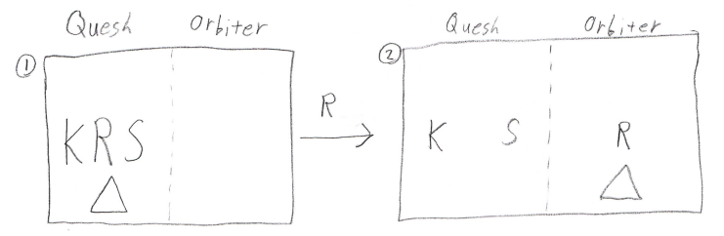 ***Figure 1—***State transition diagram. In the image, K represents Kylo, R represents Rey, S represents Snoke, D represents the ship, the left of the dotted line is Quesh, and the right side of the dotted line is the orbiting ship.

## 1.1 Full semantic network

Figure 2 shows the full semantic network created through generate and test techniques. States were generated by creating a state for each possible action. The generator did not create a candidate state for invalid moves. The tester then analyzed the generated states and eliminated them based off two tests, explained below. States eliminated by the tester are indicated by a **diagonal** line through them and the **reason** for elimination at the top right of the line.

Firstly, a state was eliminated if the state was **already represented** in the semantic network. This is indicated by a state number at the top right of the elimination line.

Secondly, a state was eliminated if the generated state was an **invalid** state. For example, if Kylo and Rey were at the same location alone without the ship (state 5). This is indicated by an “i" at the top right of the elimination line.

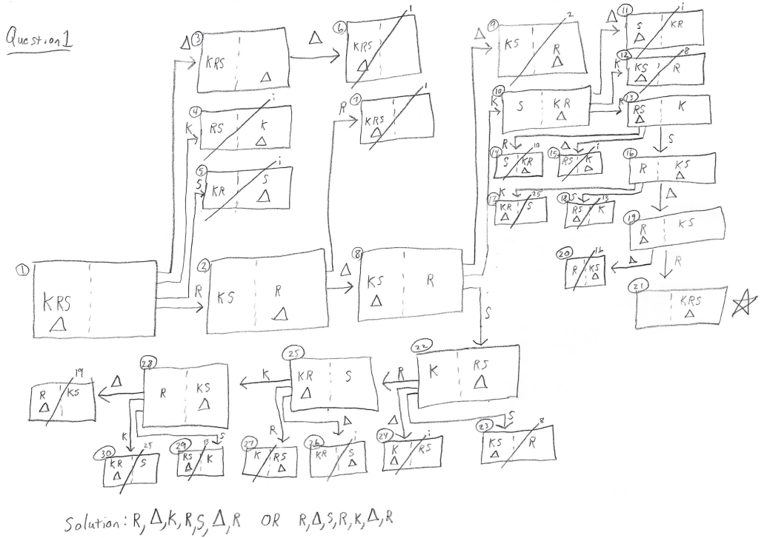***Figure 2—***The full semantic network developed for the Star Wars environment. The solution sequence is displayed at the bottom of the figure.

# 2 Smart UNO

To create a smart UNO agent, I tried to think of the strategies I usually use when playing UNO. The idea is to play skips and draw 2s as often as possible as the priority. This *lowers* the number of cards I have while either *adding* cards to other players or *prohibiting* them from playing. The next highest priority is to play cards for which you have multiple copies. If neither of these criteria apply, you play a legal card for which you have the most of a legal color or number. For example, if a blue 7 is played, I would attempt to play a blue skip or blue draw 2. If I had neither of these cards, I would see if I had multiple copies of a blue card or a 7. If I didn’t, I would play a blue card or 7 card that I had multiple copies of. If I still hadn’t found a match, I would see if I had a valid non-wild to play. If I did, I would play the card which I had the most of its color or number. If I did not have a valid card, I would play a wild if I had one. If I did not, I would draw until I had a valid card to play. Figure 3 shows the flowchart created from these production rules.

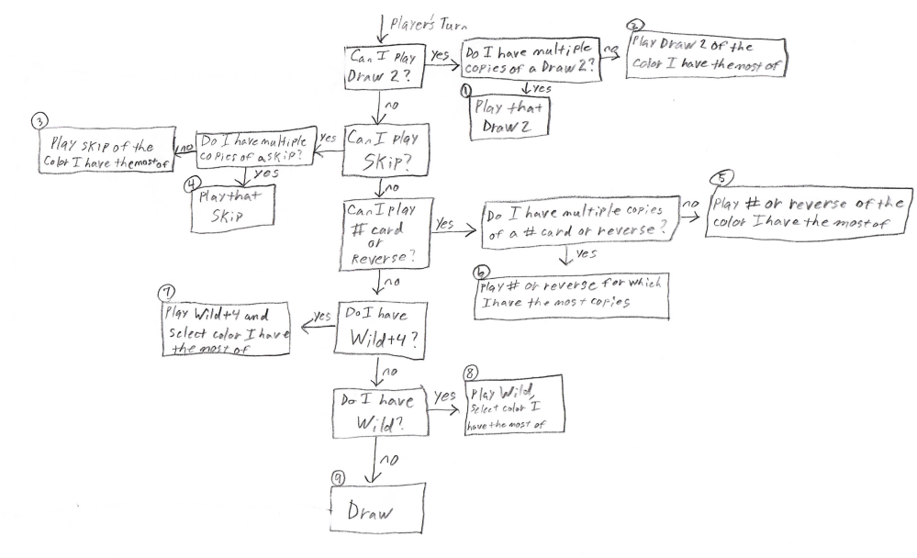

***Figure 3—***Flow chart illustrating production rules. When the question asks if I have multiple copies of a card, I would prioritize playing exact copies of a card and then prioritize playing different colored copies of a card. For example, if a blue 7 was played and I had 2 green 7s and a red 7 in my hand, I would play a green 7.

## 2.1 Trial by fire

Below in Figure 4 is the log of the UNO game I played using my flowchart. Each decision noted in the log can be found in Figure 3. The agent would do better if it knew the size of the other player’s hands and could strategically play reverse cards to prevent players with small decks from playing. I could implement this in my flowchart by breaking the # and reverse check into two separate checks. My agent already captures the strategy of leaving a wild as your **last card** to play, but it could keep track of colors that other players have not been able to play. If it did that, it would be able to consider selecting a color that other players would struggle to play on instead of just selecting a color based on the cards I have. I could keep track of colors that other players have been unable to play on to make this strategy a reality.

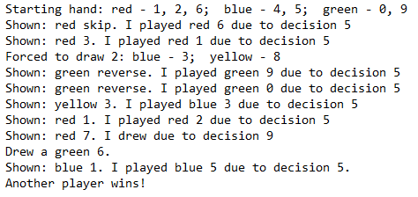

***Figure 4—***Log from playing one round of UNO using flowchart from Figure 3.

# 3 General Data Protection Regulation (GDPR)

The GDPR is a law passed by the EU to enforce privacy and security online (Wolford, 2018). It outlines when it is legal for organizations to collect and make use of users’ personal data. Generally, organizations cannot make use of information that could be used to directly or indirectly identify the individual for which it applies. This is to maintain the right to privacy as outlined in the 1950 European Convention on Human Rights (Wolford, 2018). Article 6 of the GDPR lays out the specific instances when this is okay. If an organization wishes to use personal data to offer a personalized user experience online, they will most likely take advantage of the GDPR’s allowance under **unambiguous consent**.

## 3.1 But what is consent?

A user’s consent must meet specific criteria. The organization must specifically ask for consent using “clear and plain language” while explaining for what the user is agreeing to (GDPR, 2018). The user will be able to easily withdraw consent at any time and the organization must keep evidence of consent (GDPR, 2018). Additionally, users under the age of 13 must get consent from a parent (GDPR, 2018). Once all these conditions have been met, the organization may make use of the user’s personal data, provided they explained what data they would use, how they would use it, and abide by that agreement.

If a company wanted to use **artificial intelligence** to create a personalized experience to their users, they would need to ensure the AI agent would only operate under the outlined provisions of the consent statement. If for instance, a company was collecting search histories to anticipate a user’s search, they would get the user’s consent for that information. But if the AI agent used the user’s search histories to offer personalized advertisements that would interest the user, the company would be operating outside the scope of their compliance statement and would be in violation of the GDPR.

## 3.2 Facebook

Facebook is a company which offers a personalized experience to each of its users. Each user can build their own account, fill it with personalized information, and then share that information with other users across the globe. This is not a violation of the user’s right to privacy as they are required to agree to a compliance statement. Facebook is then responsible for ensuring their users’ information is handled according to individual privacy settings. These privacy settings are a sort of fluid compliance statement because they determine the scope of information availability for an account and can be changed at any time.

When users make accounts on Facebook, they are not waiving their GDPR rights. Rather, they are entrusting Facebook with some of their personal information and allowing Facebook to use that information in a specific way. The user retains the protection the GDPR offers for anything outside of the compliance statement. Facebook is always liable for any misuse of the information provided to them as well as any unintentional leak of personal information.

# 4 Watson’s intelligence

Watson is a knowledge-based AI agent which can play Jeopardy. It takes as input an answer, searches through its memory for a question to match the answer, and then returns the question which best matches the answer. Watson is very good at its job and beat out Ken Jennings and Brad Rutter, “two of the show’s all-time winningest contestants,” as stated in the homework description. So, is Watson more intelligent than these two individuals?

## 4.1 What is intelligence?

Intelligence refers to an agent’s ability to **react well** in an environment it is placed in. The agent can observe the environment through a series of inputs. It then processes these inputs, decides upon an action, and then interacts with the environment with an output. How well it reacts with the environment is a measure of its intelligence.

This could be a student in the environment of a classroom during a test. The input the student receives is a test and the student’s ability to react well is judged on how it answers these questions, the output. The student has a variety of ways to decide upon a reaction to the test. It could use past knowledge to answer the question, answer randomly, or even crumple up the paper and throw it in the trash. This decision-making process manifests itself differently in different agents and is illustrated in Figure 5 as the Cognitive System box.

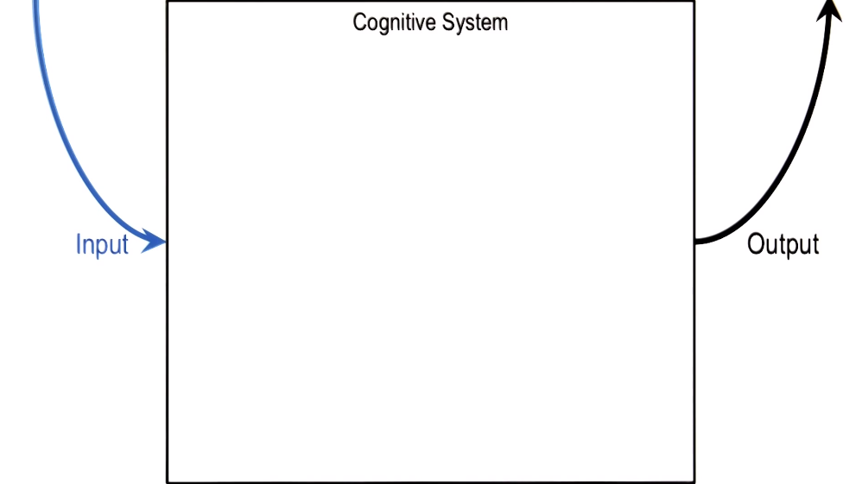

***Figure 5—***Illustration of an agent taking observations from the environment as input, going through some sort of decision-making process, and then performing actions in the world as output.

Notice that the measure of an agent’s intelligence is dependent on the **environment** the agent is placed in. For instance, a mole is highly intelligent on the subject of burrowing underground. It can observe the environment around itself and burrow to its heart’s content. Swans, on the other hand, are not intelligent on the subject of burrowing underground, but are very intelligent when it comes to swimming on a lake. If the swan was placed underground and the mole was placed on a lake, the two would appear unintelligent.

In the same way, Watson is highly intelligent in the environment of a Jeopardy game. In fact, Watson is *objectively* more intelligent within this environment than Ken Jennings and Brad Rutter: Watson won more money than both contestants combined. However, this measure of intelligence is too small in scope to judge an agent’s overall intelligence.

## 4.2 A universal equation

Watson is **not** more intelligent than Jennings and Rutter. Let IA,E be the intelligence of an agent, A, in environment E. Additionally, let the function A(i) be a mapping of inputs to outputs where i is an input and the output is determined through our agent’s decision process. Finally, let VE(o) be a value function for outputs, o, within a specific environment, E. We have already established that an agent’s intelligence in a particular environment is how well it performs in that environment. Therefore, IE,A = . In other words, an agent’s intelligence in an environment is a measure of how well it performs over all possible inputs. If we apply this formula over all environments, we are able to measure an agent’s overall intelligence, regardless of environment. The equation becomes:

IA =

***Equation 1—***The intelligence equation. An agent’s, A, intelligence is equal to how well it performs for all inputs in all environments.

Assuming Watson is not able to perform very well outside of the environments of Jeopardy and being a paperweight, Jennings and Rutter have higher overall intelligence even though they are less intelligent within the Jeopardy environment. This is due to their ability to adapt to new environments and process and interpret a much wider variety of inputs.

# 5 REFERENCES

1. General Data Protection Regulation. (2018, May 25). Retrieved May 26, 2020, from https://gdpr.eu/tag/gdpr/
2. Wolford, B. (2018). General Data Protection Regulation (GDPR) Compliance Guidelines. Retrieved May 26, 2020, from https://gdpr.eu/